Card Special

User Guide

|  |  |  |
| --- | --- | --- |
| Supervisor. |  |  |
| Batch. | 2303E1 |  |
| Group. |  |  |
| Serial No. | Enrollment Number | Student Name |
| 1. | 1460453 | Muhammad Asim |
| 2. | 1456781 | Hiba Shah |
| 3. | 1458615 | Khizar-ul-islam |
| 4. | 1456770 | Rao usama |

Used to select the language displayed on the website:

When the user selects the American flag icon, the link to the Web page displays the English language.

 When the user selects the Vietnamese flag icon, the link to the Web page displays the Vietnamese language.

|  |  |
| --- | --- |
| 2 | Layout Top |

English e-Muta



# Figure 2: Upper Frame Interface

2.1.1 Language Section

When clicking the Language button, the system will lead to the page to select the language. (0.index.html)

2. I .2 contact us Section

When you click the Sign In button, the system will display the login window.

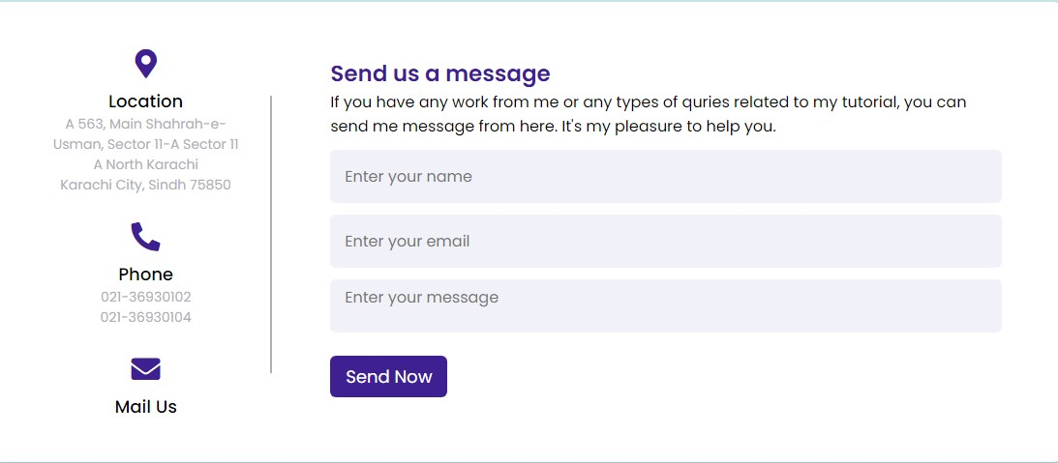

Figure

3:

Contact us section

2.2 Menu Bar

HOME ABOUT CARDS BRANDS CONTACT US

# Figure 7: Menu Bar

Used to load the remaining pages. The following is a list of those pages:

Home Page (lndex.html)

ABOUT PAGE(About.html)

 CARDS

* Birthday (Product-Birthday .html)
* Wedding (Product-Wedding .html)
* Business (Product-Business.html)

 BRANDS

* JAPAN ART (JAPAN .html)
* INSTA PRINT (INSTA PRINT.html)

Technology Page (3. Technology.html)

Drop-down menu bar: The product tab of the Menu can be removed and contains submenus that lead to subpages. You can access these pages (main page or subpage) by clicking on its tab.

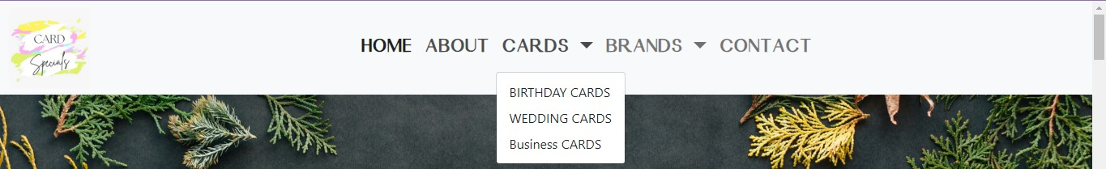

Figure

8:

Dropdown

Menu

3. Layout(Böttom1)

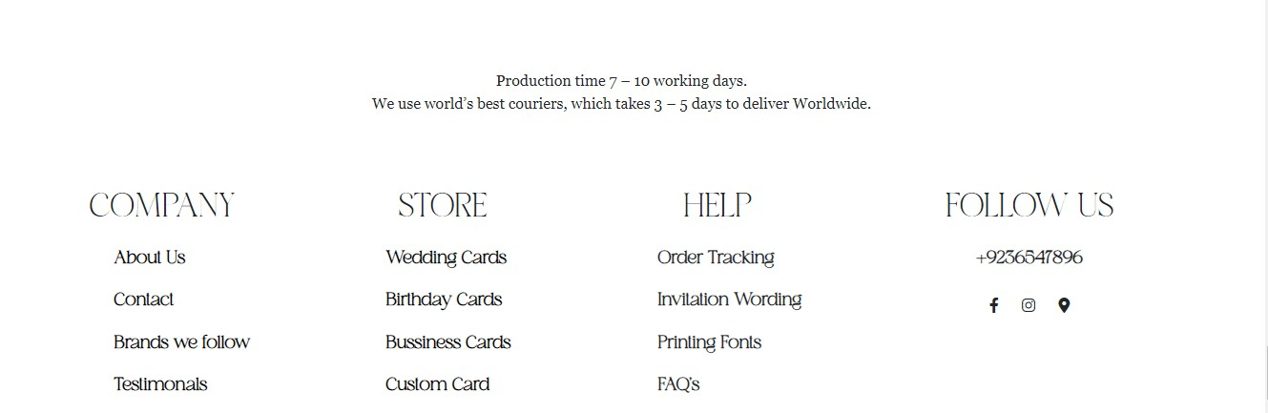

Figure 9: Layout Bottom

Display information such as menu, operating time, store information, store location on Google Map, social networks, payment methods, support data input bar and send data button. The Top button is used to push to the top of the page when clicking.

1. HOME PAGE(index.html)



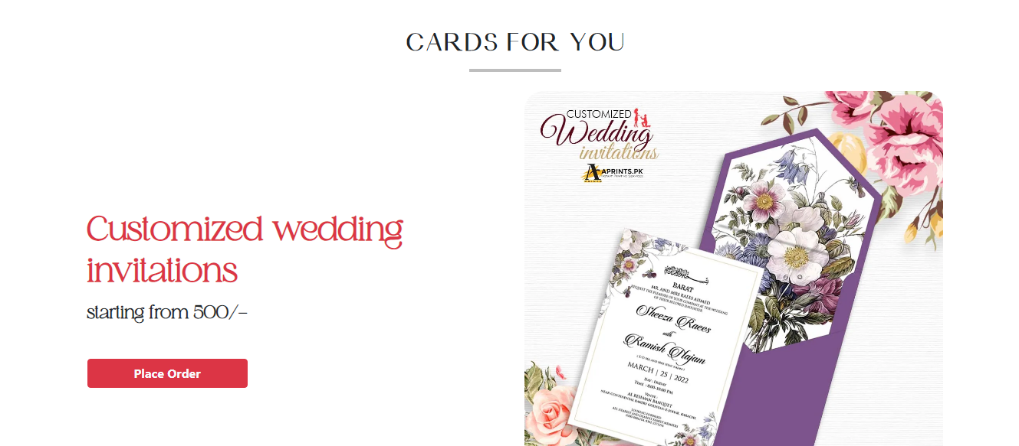

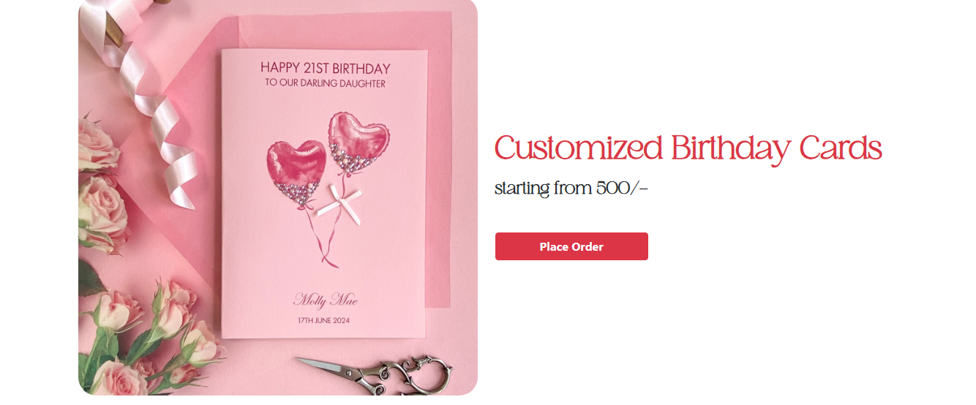

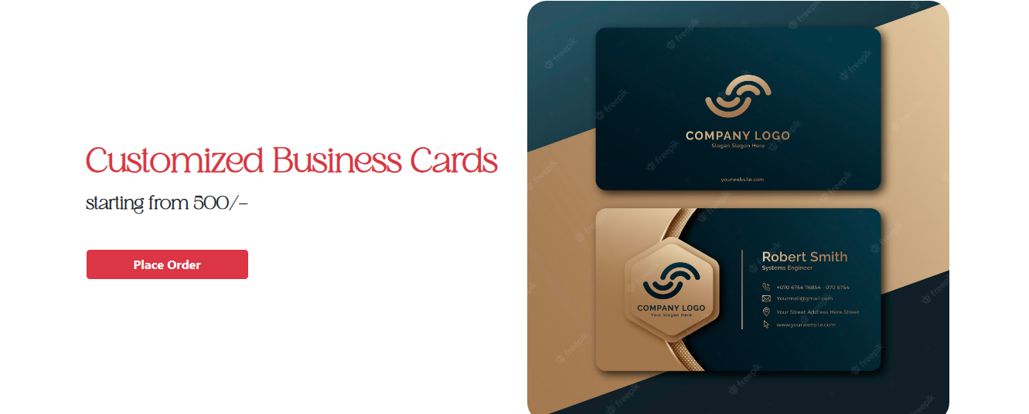

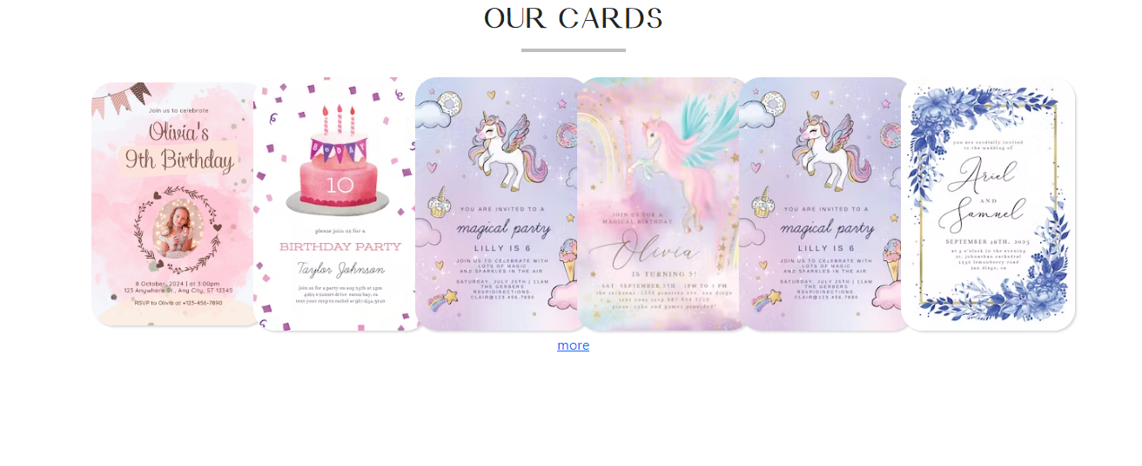

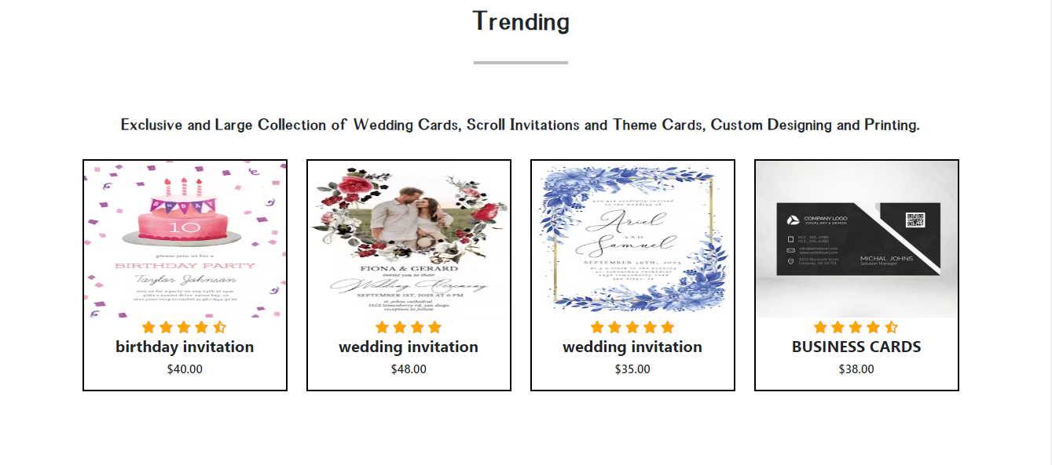

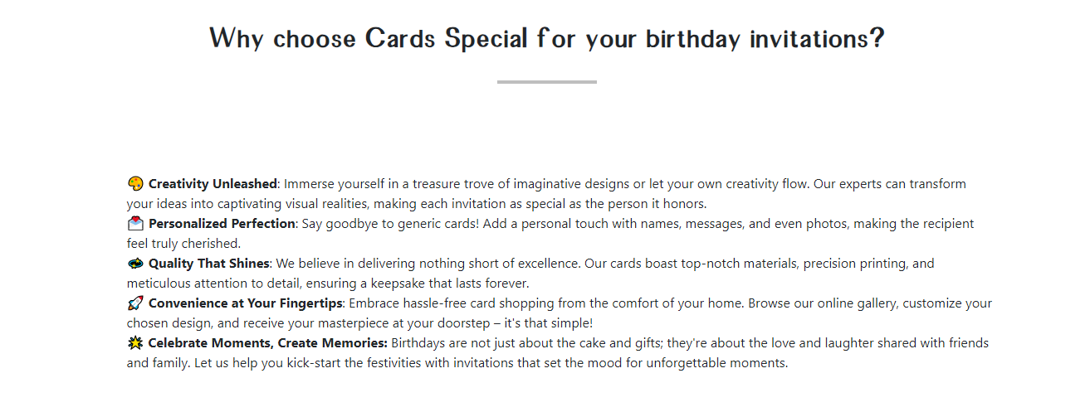 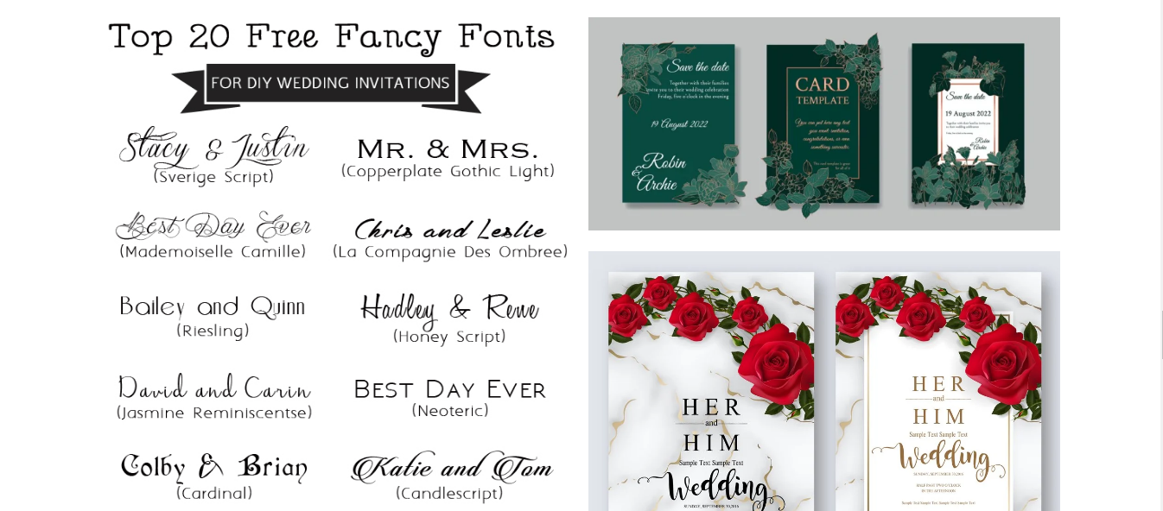

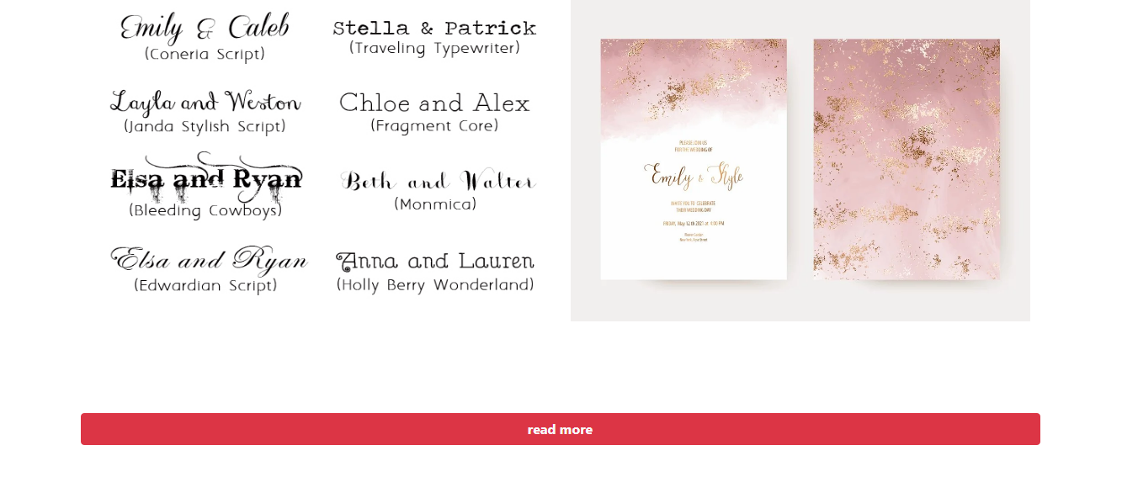

2.ABOUT US PAGE(about.html)

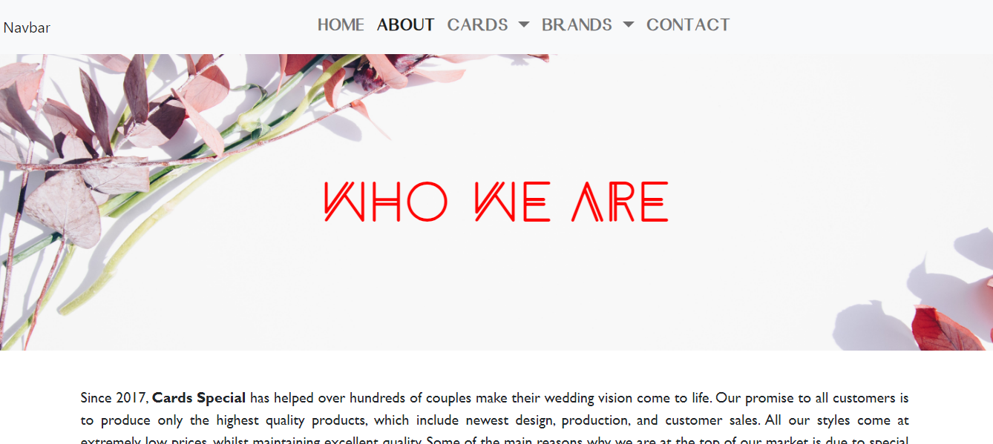

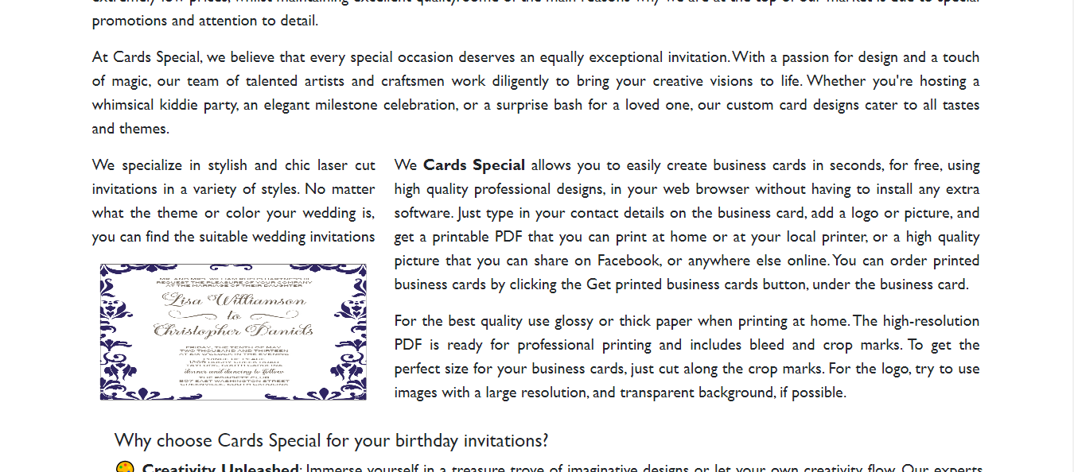

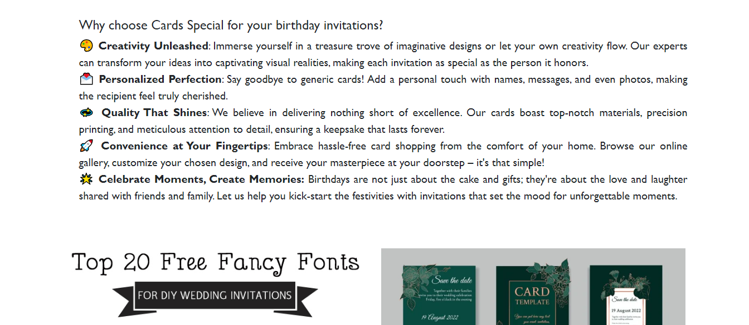

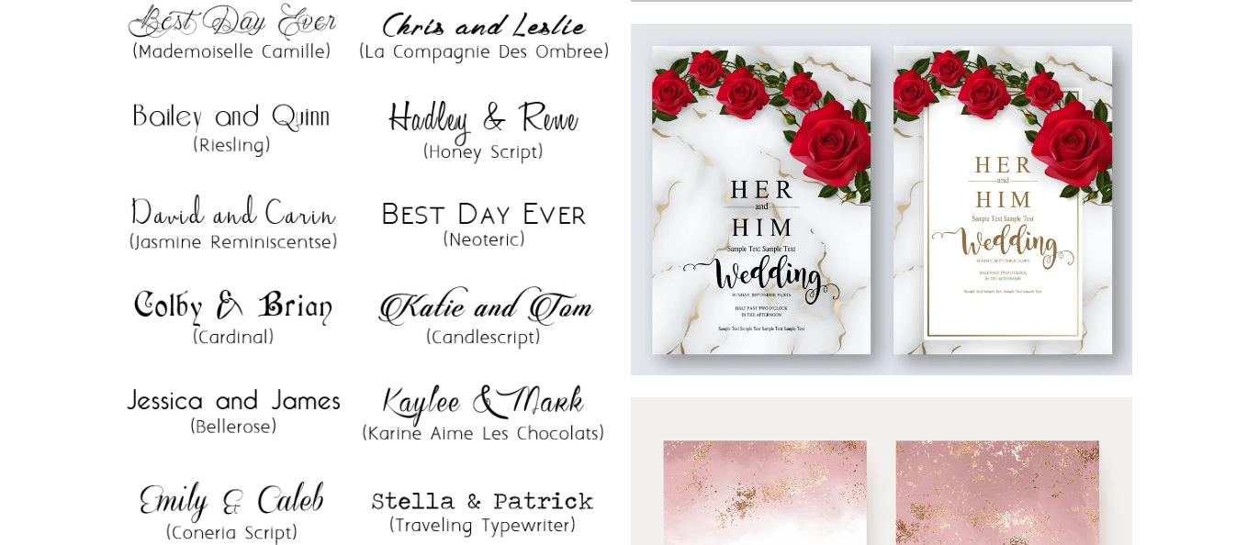

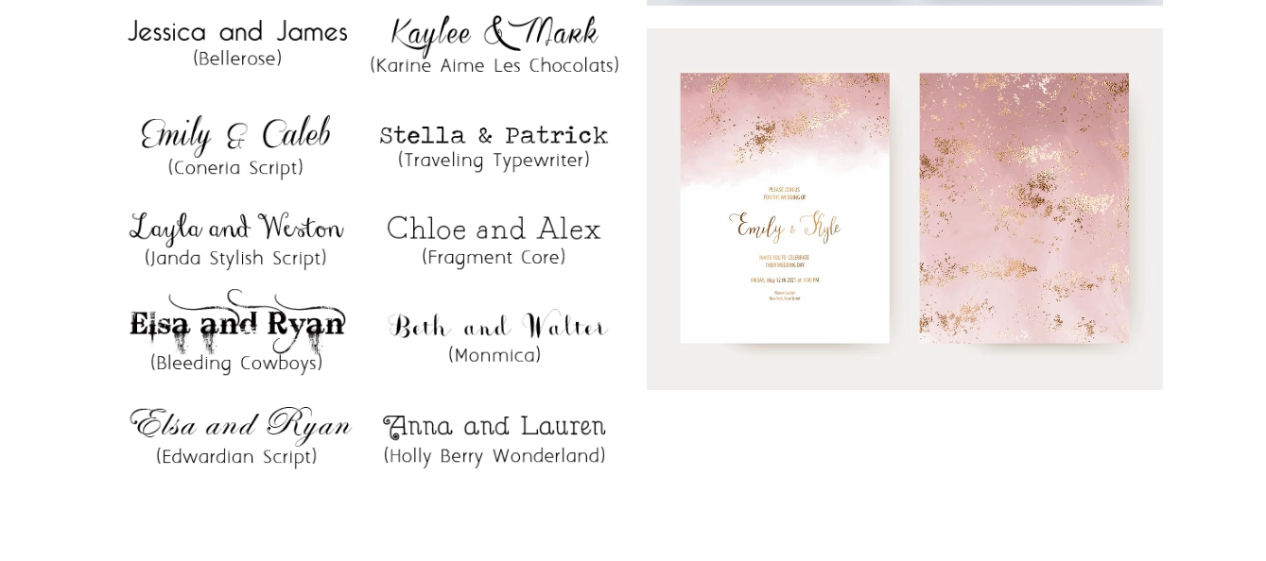

3.PRODUCT CARD

* Birthday card(birthday.html)
* Wedding card(wedding.html)
* Business card(business.html)

1.Birthday cards

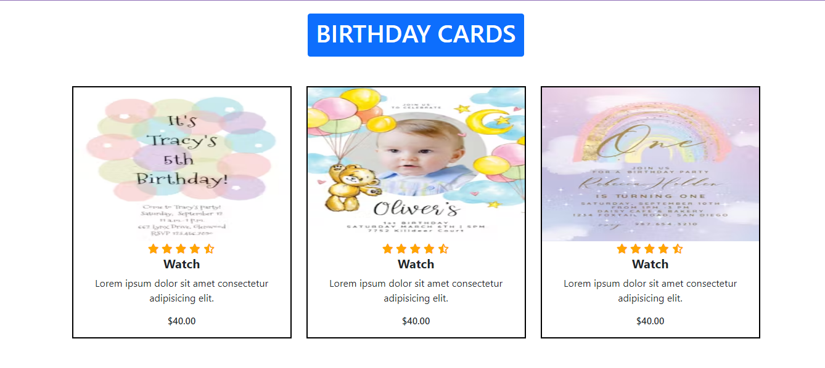

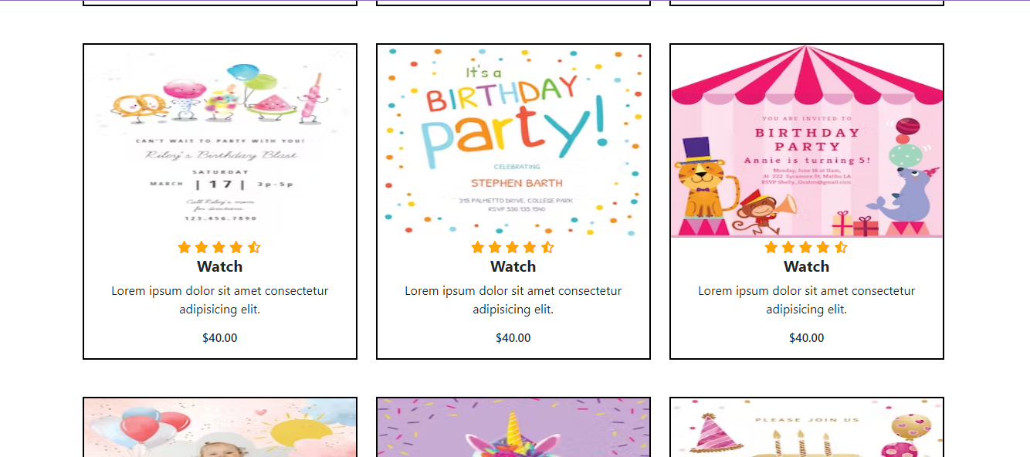

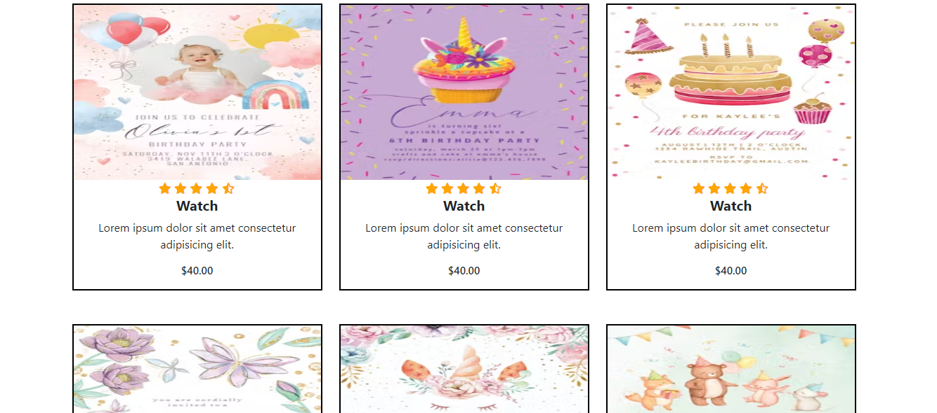

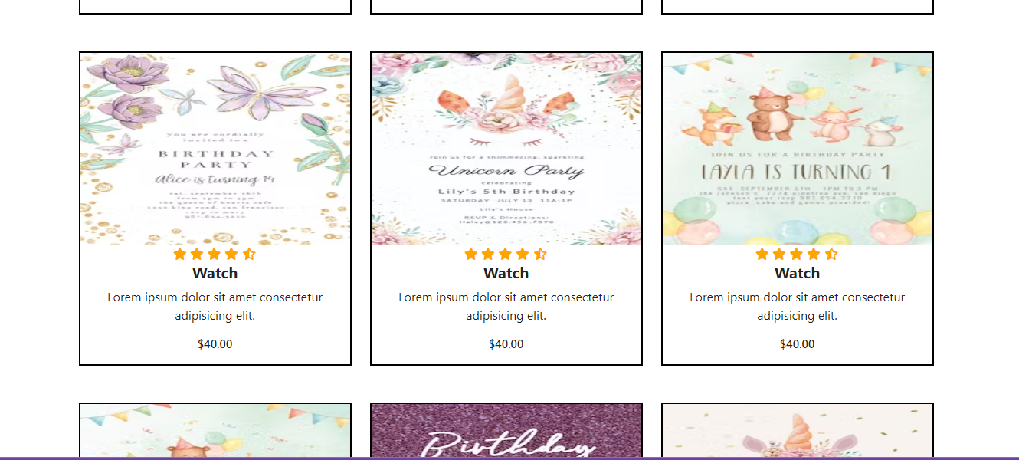

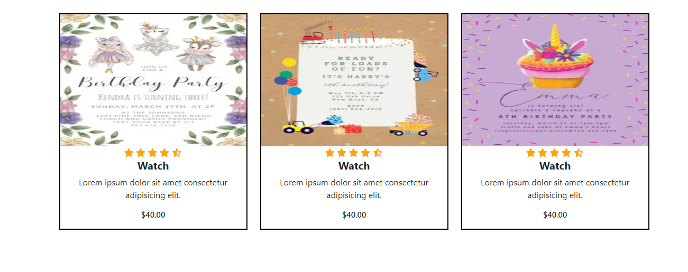

* Wedding Card

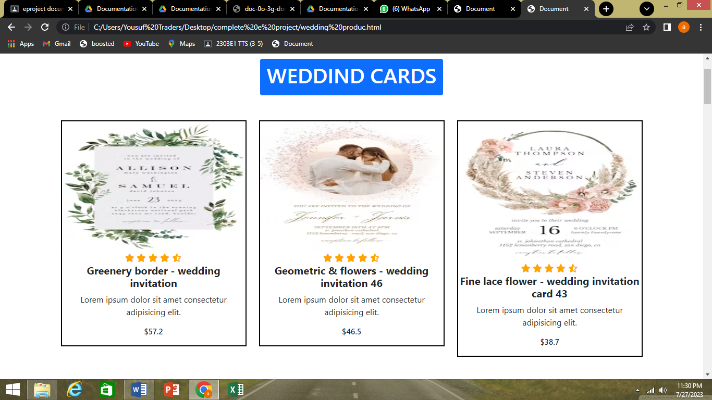

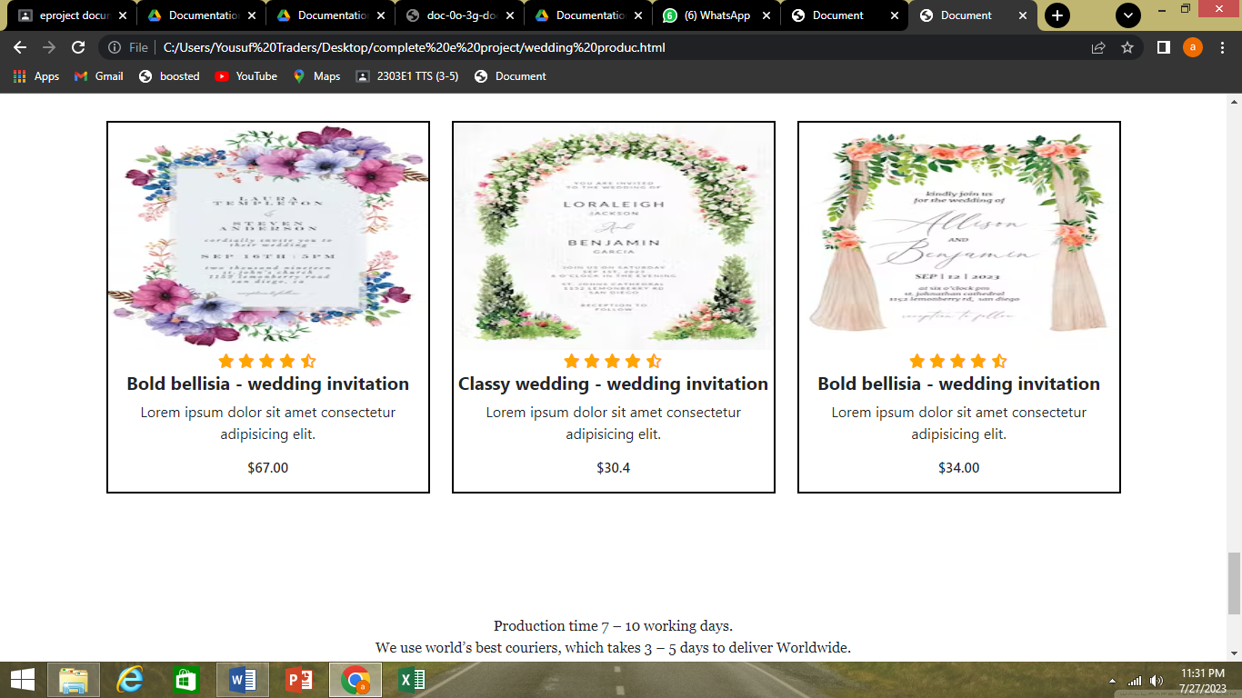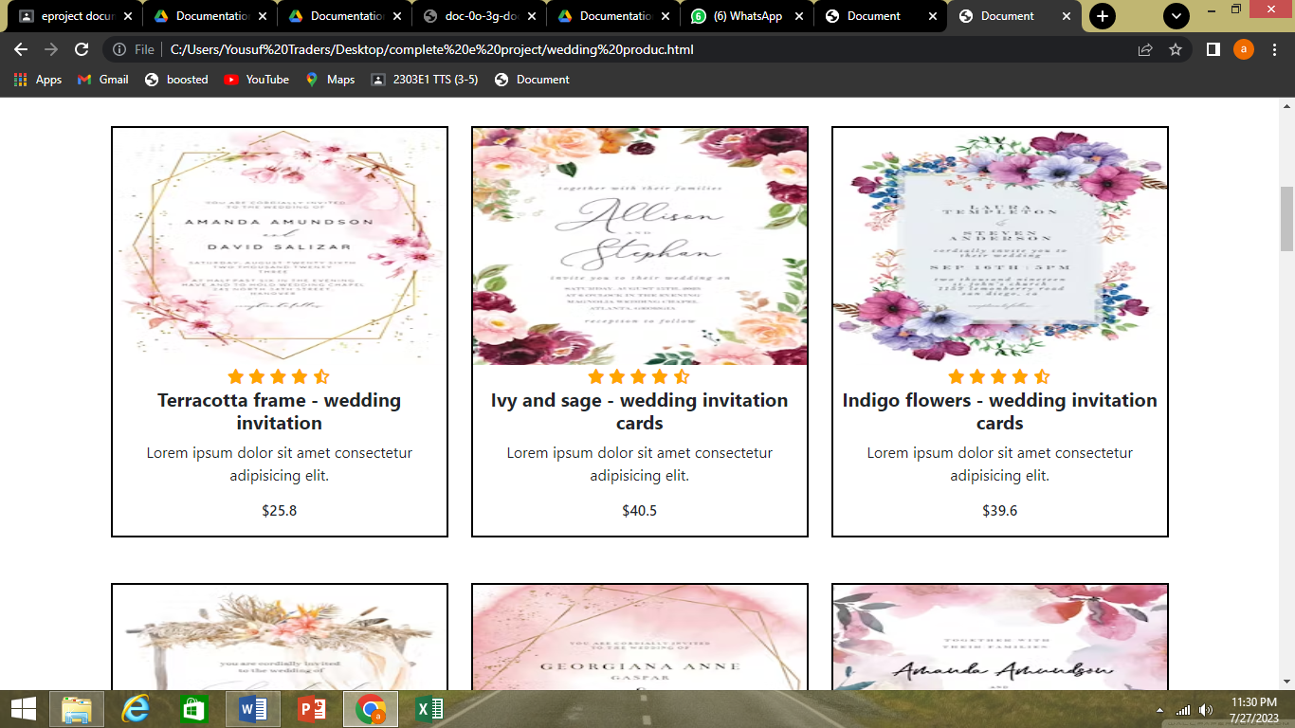

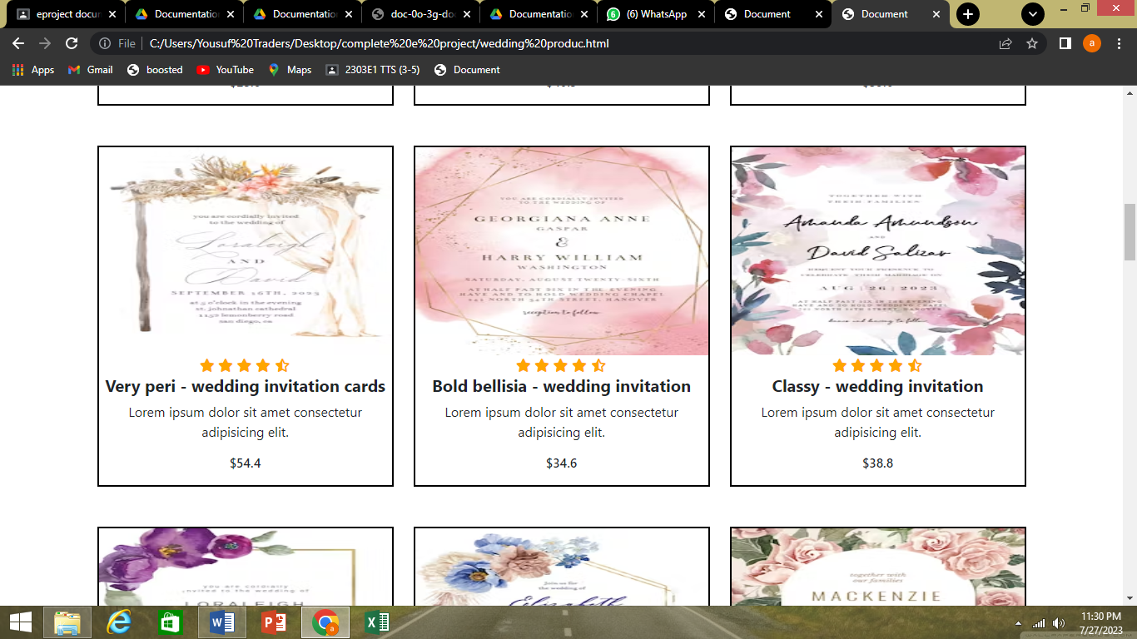

Birthday invitation

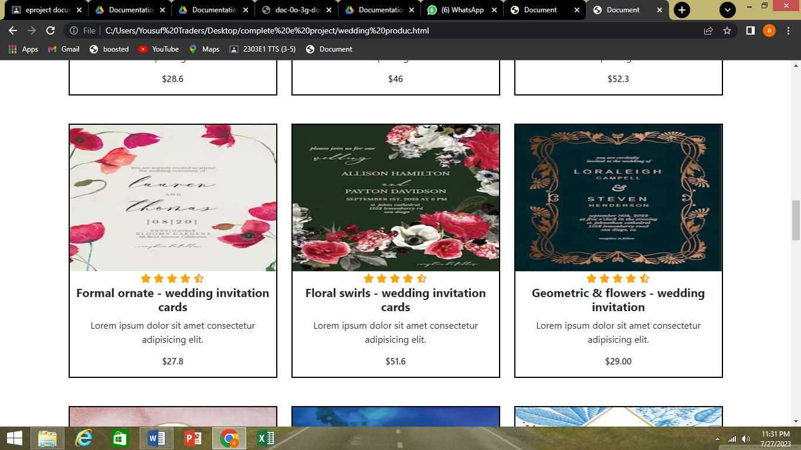

* Business cards

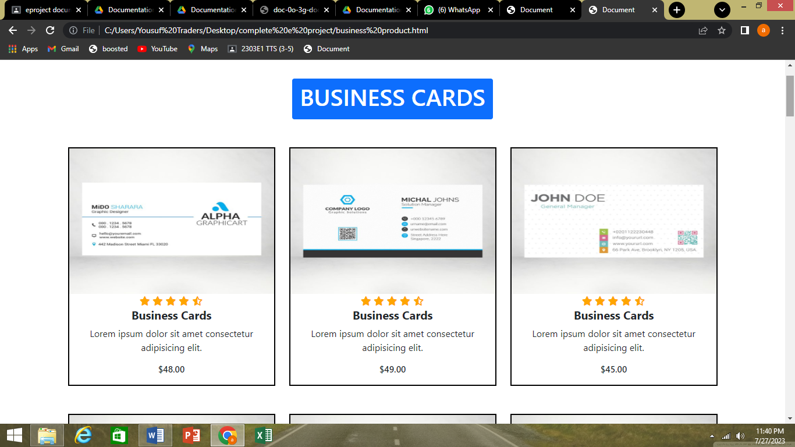

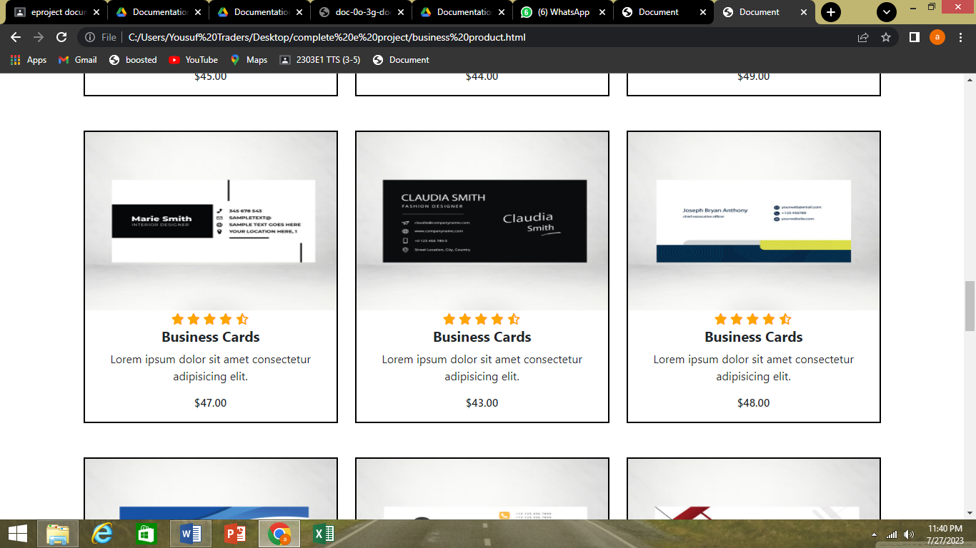

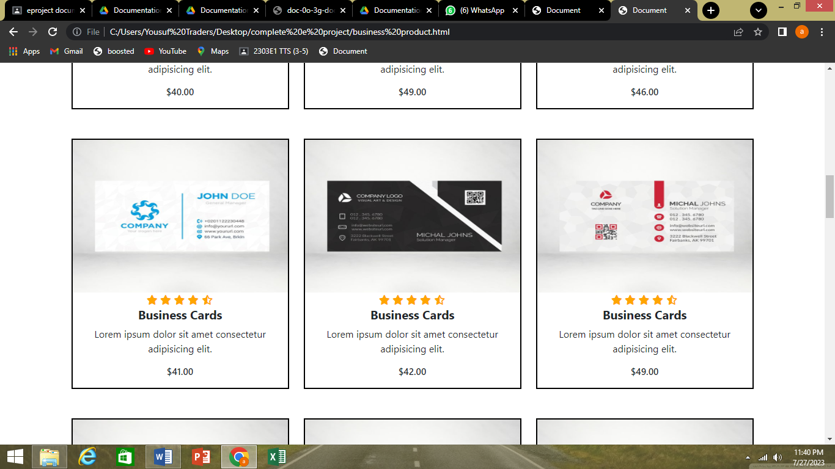

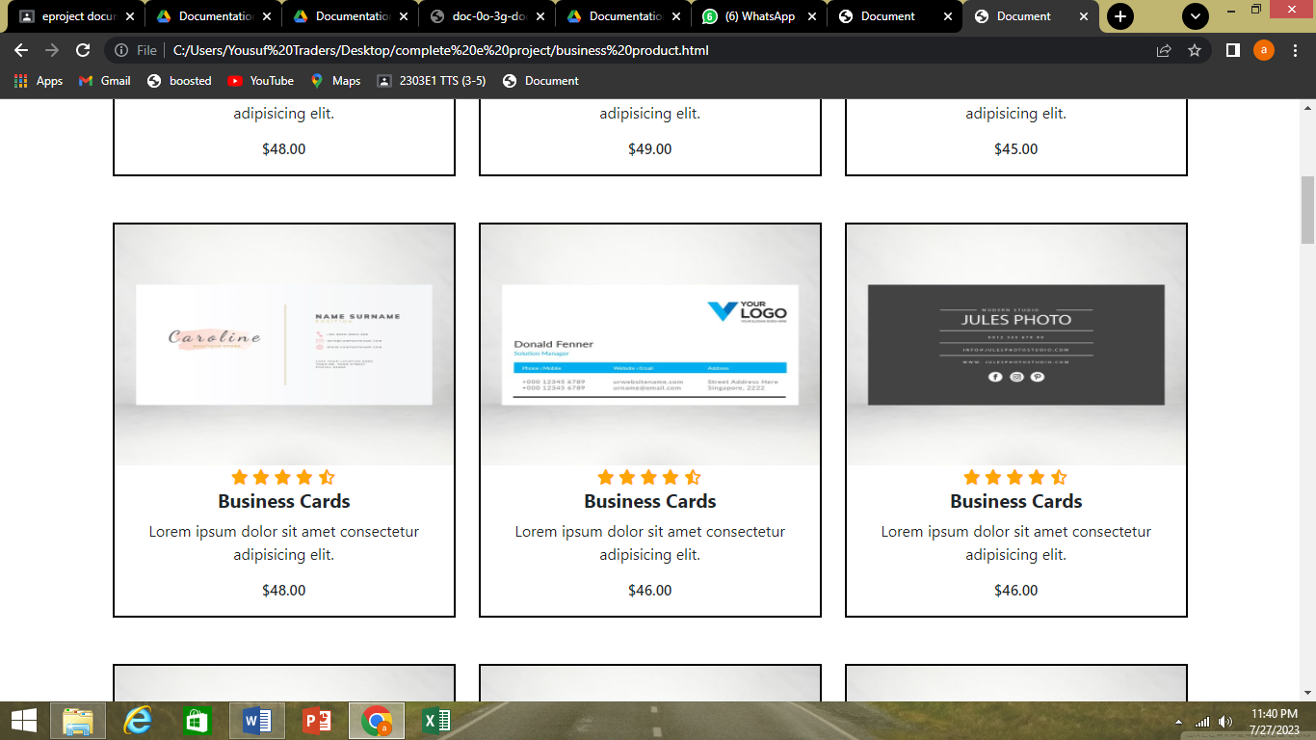

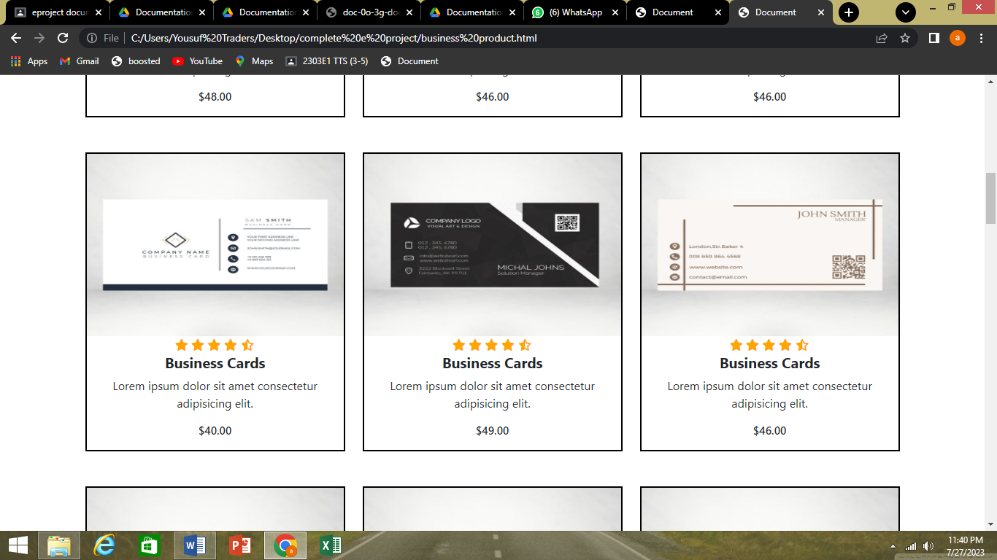

* BRANDS()
* JAPAN ART(japan art.html)
* INSTA PRINT(insta print.html)

1.JAPAN ART

* Wedding cards
* Eid Cards
* WEDDING CARDS

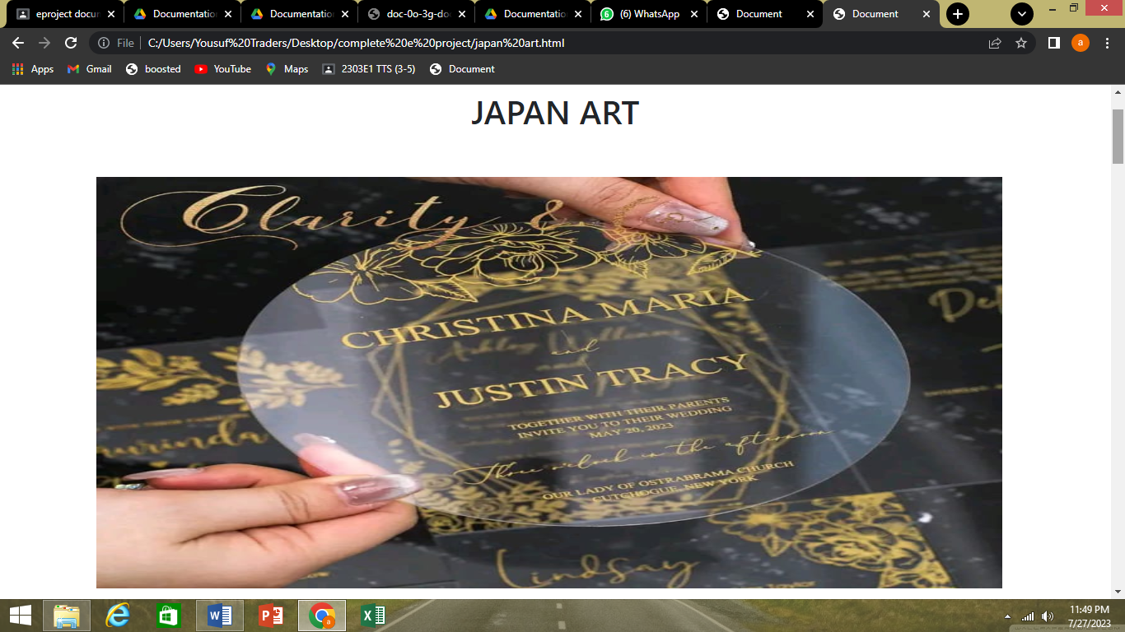

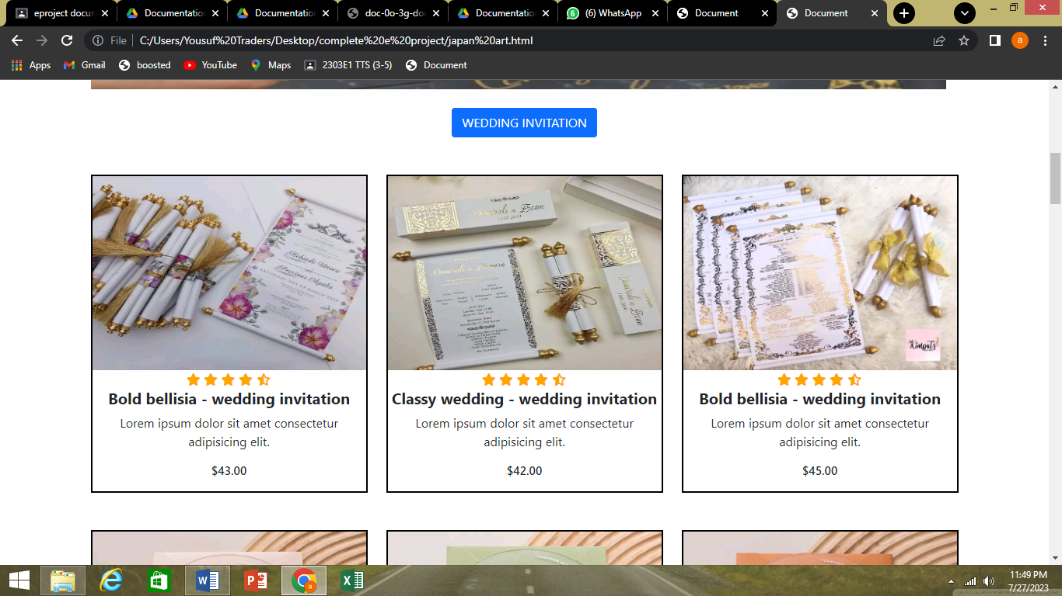

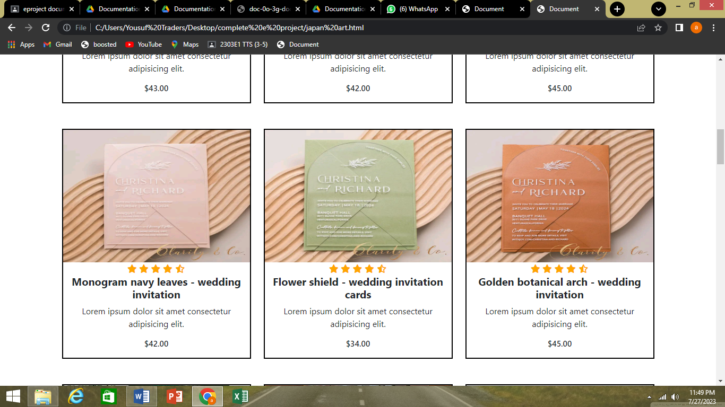

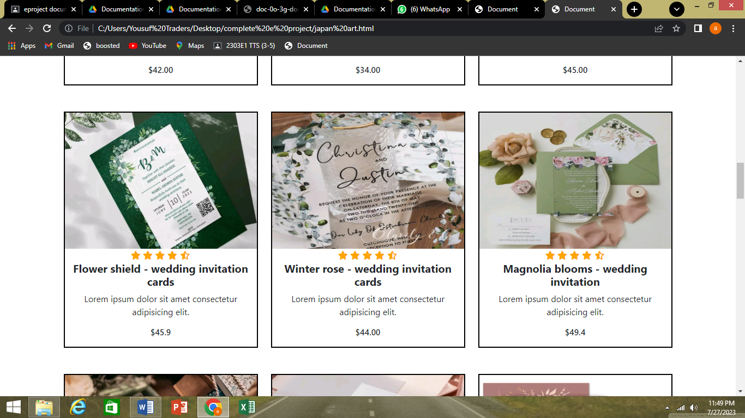

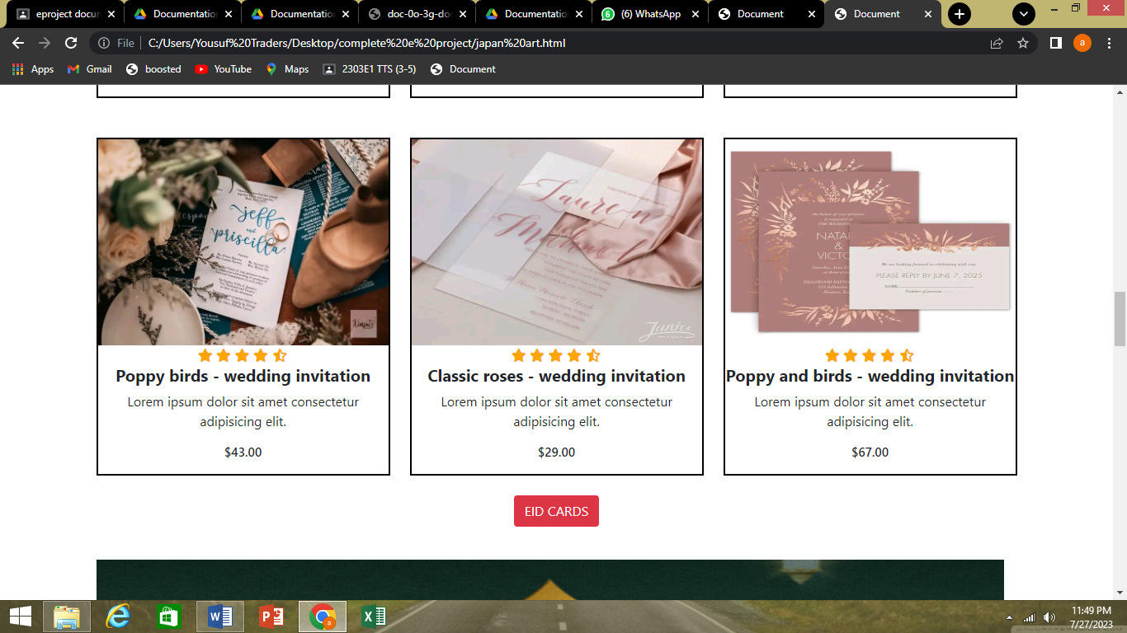

* EID CARDS

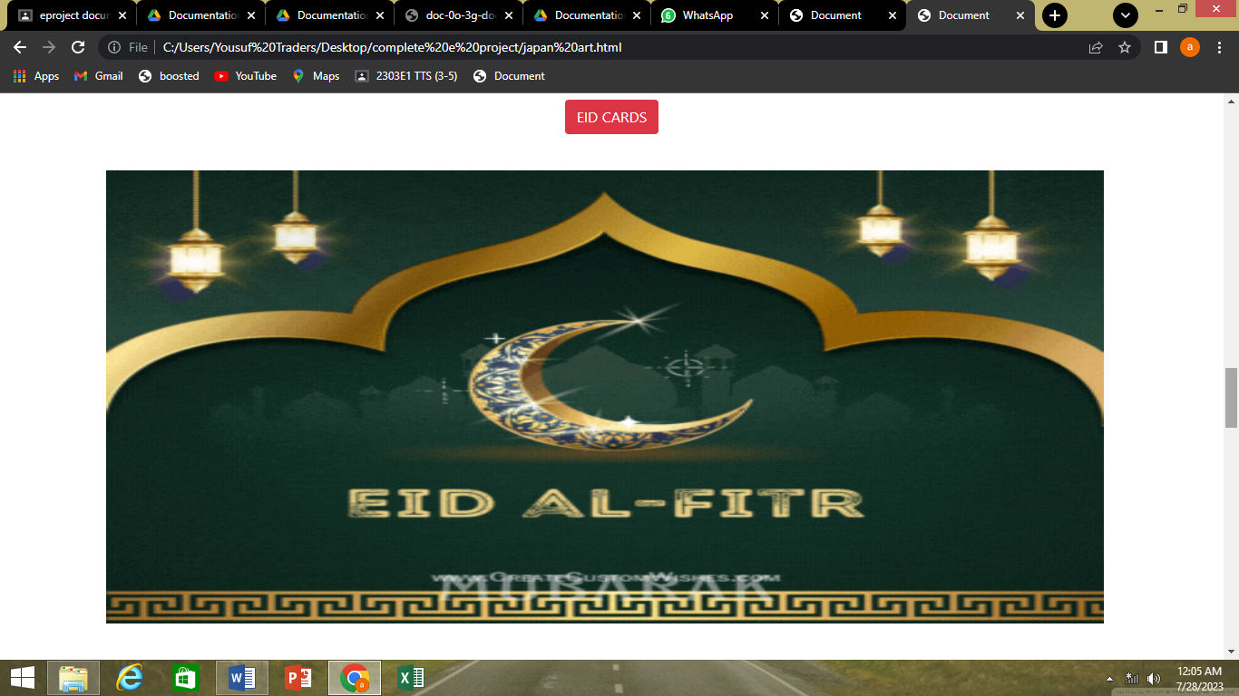

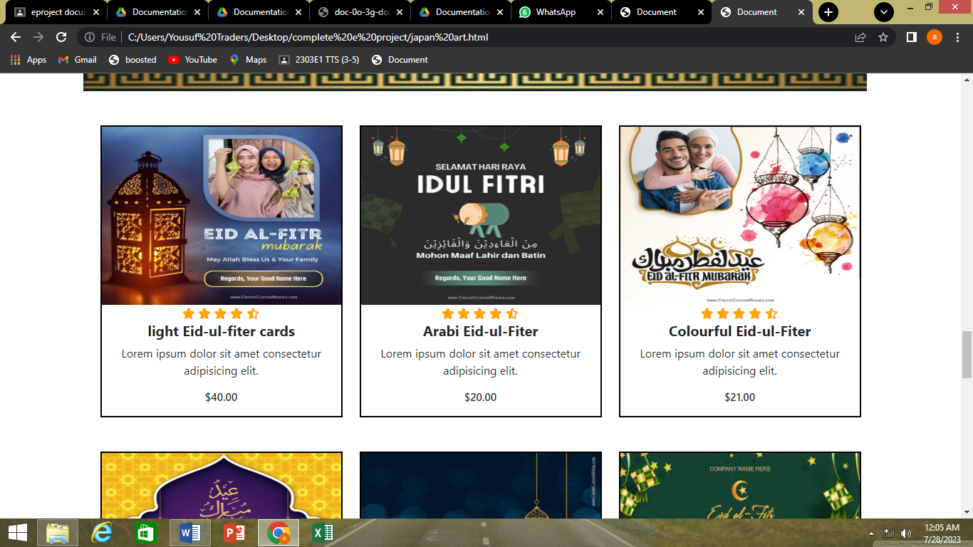

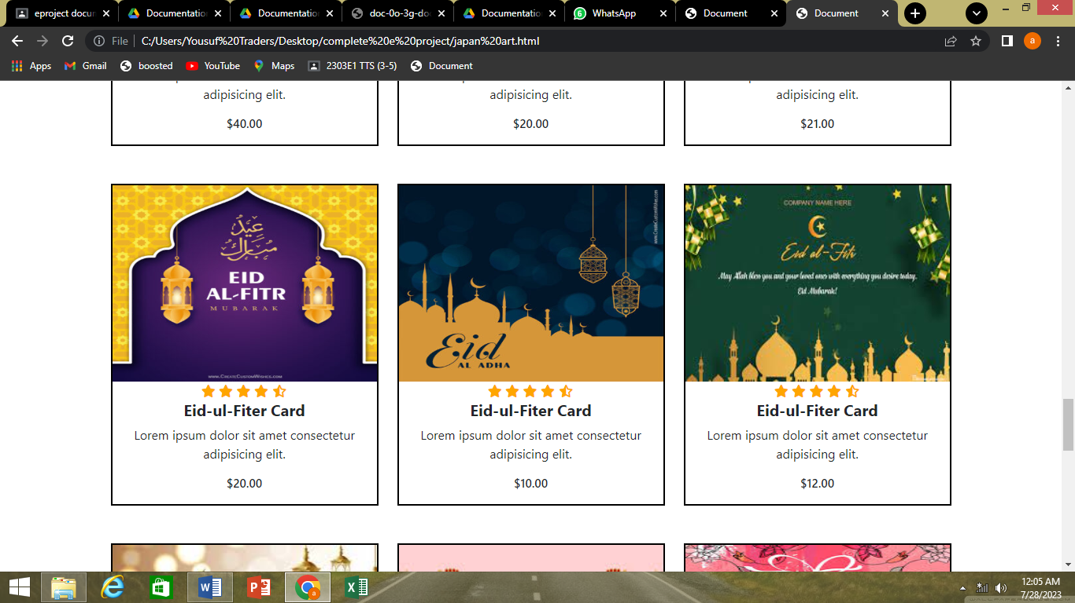

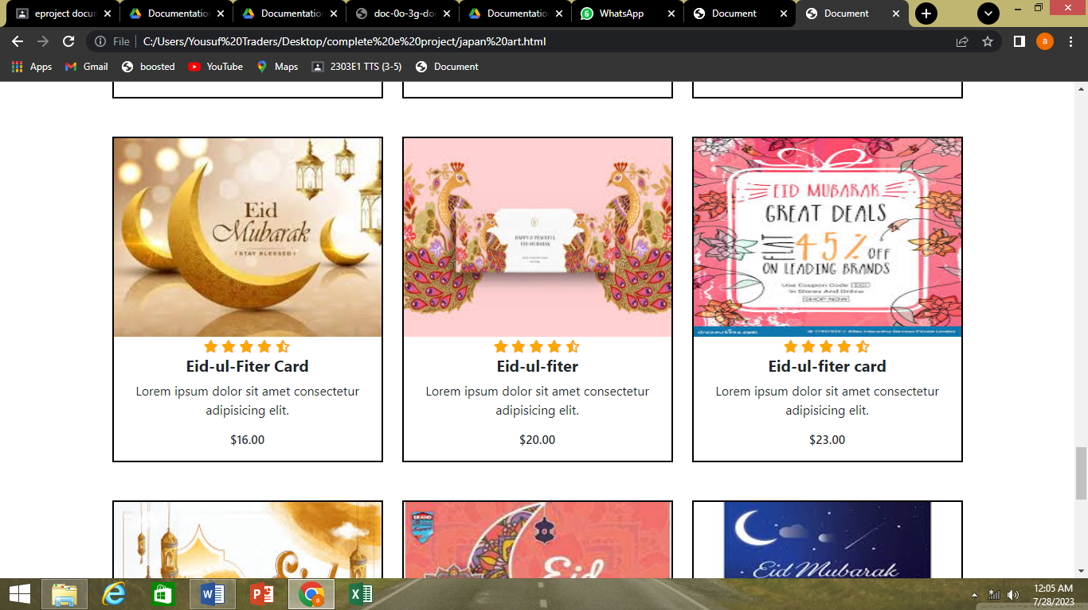

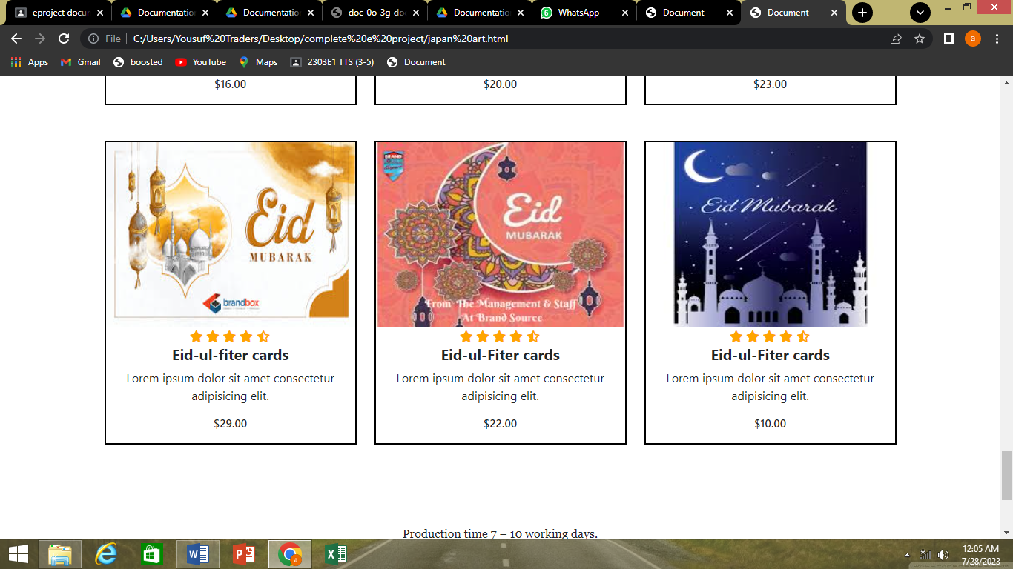

* INSTA PRINT
* Wedding cards
* Cloth Bag & Box Cards

1.WEDDING CARDS

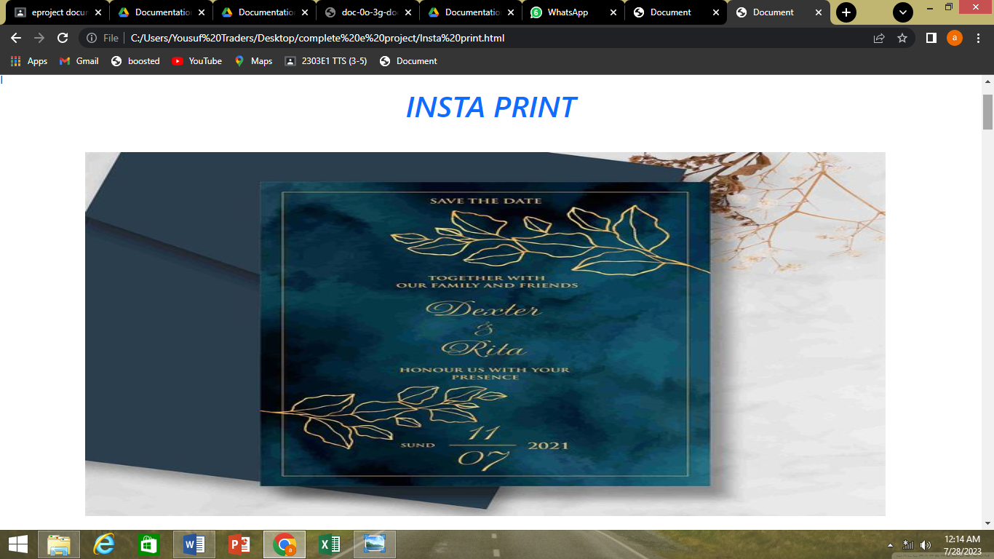

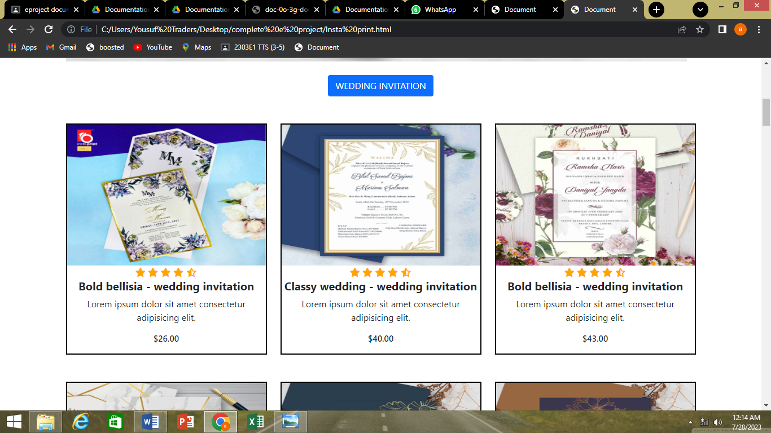

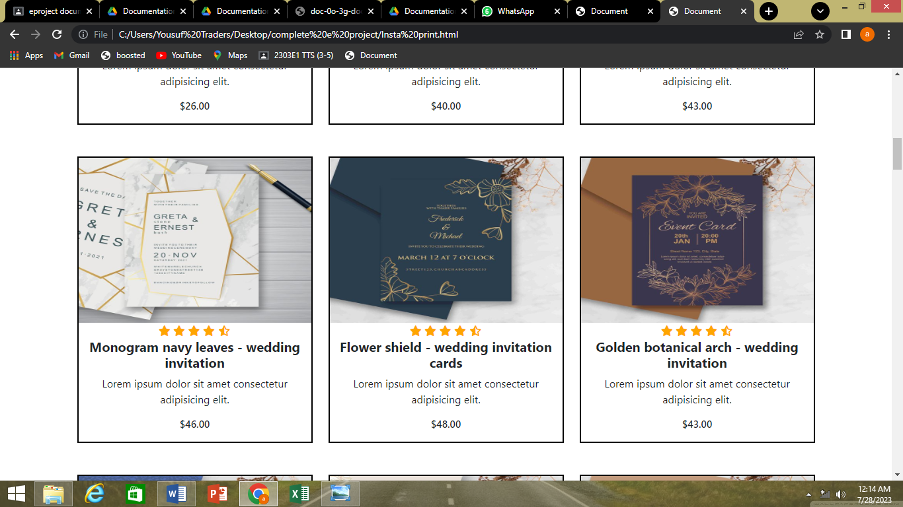

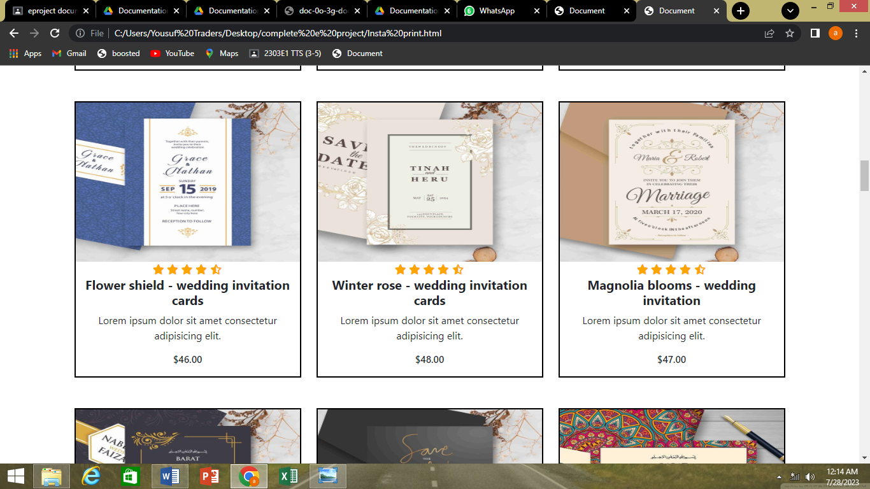

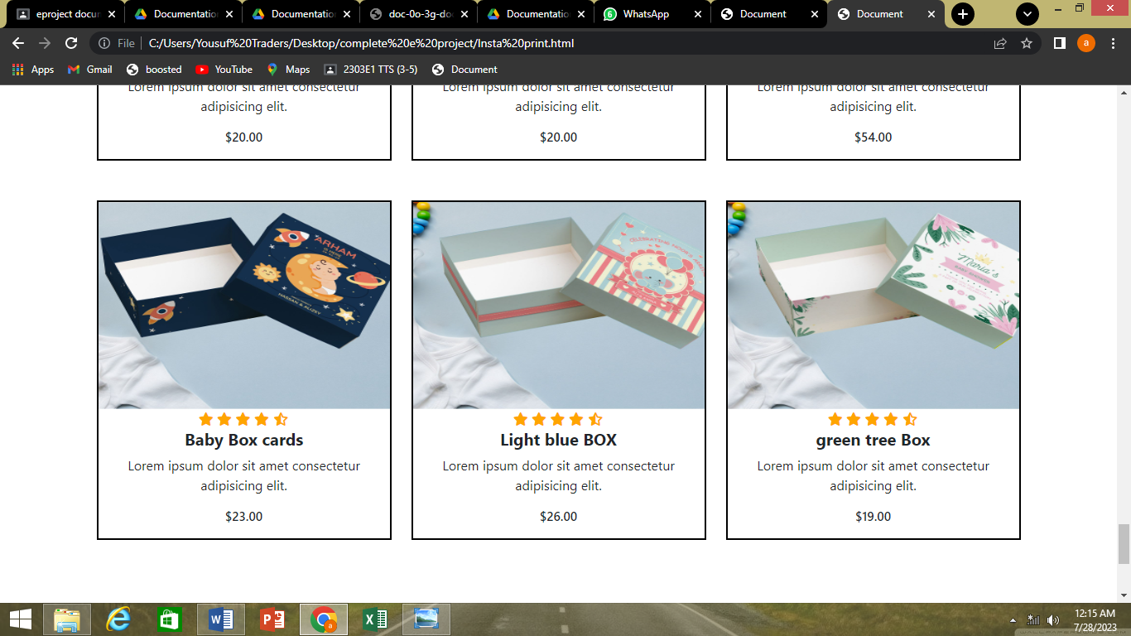

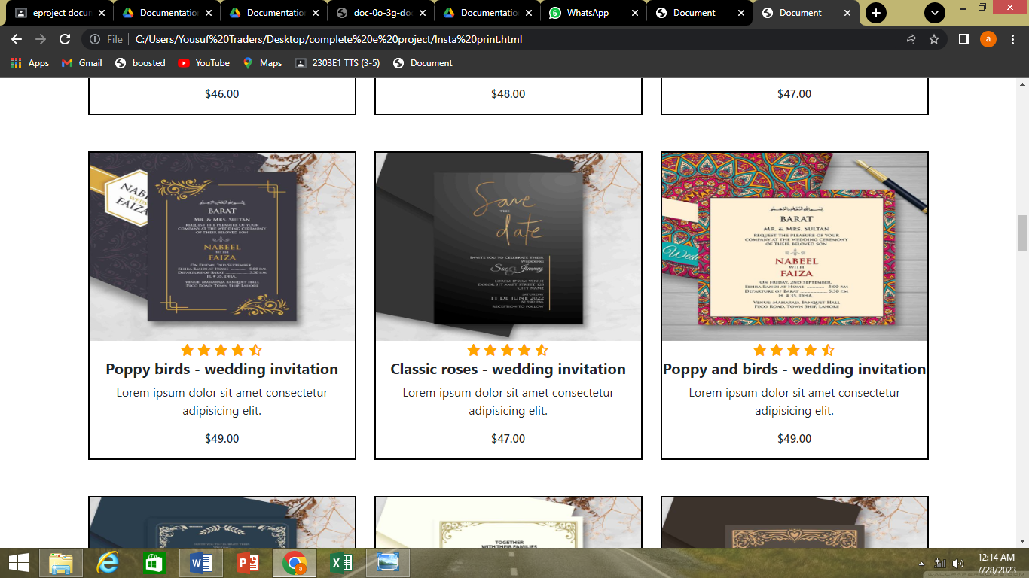

2.CLOTH BAG & BOX

